HW3_Lab_Instructions

- This lab will involve analyzing the traffic of an exploit kit.
- You will use your Windows 8.1 RADISH Virtual Machine for this lab.
- Copy the Wireshark Installer from the M: Drive \ Tools Folder to the Desktop of your VM.
- Run the Wireshark installer, use the .\student and student local admin credentials for the UAC, and select all of the default installation settings for Wireshark and WinPCAP.
- You will also need to turn off Windows Defender from Windows 8. Search for Windows Defender and once it is open, click on the settings tab and remove the check from “Turn on real-time protection” and select “Save changes.” Use your local admin credentials.
- A packet capture file (malwarewinxp1.pcap) containing the traffic and files from a real Exploit Kit infection is located on your M: Drive \ Tools folder. Copy that file to your Desktop.
- Double click on the packet capture file to open it with Wireshark and resize the three panes to look similar to the figure on the next page.

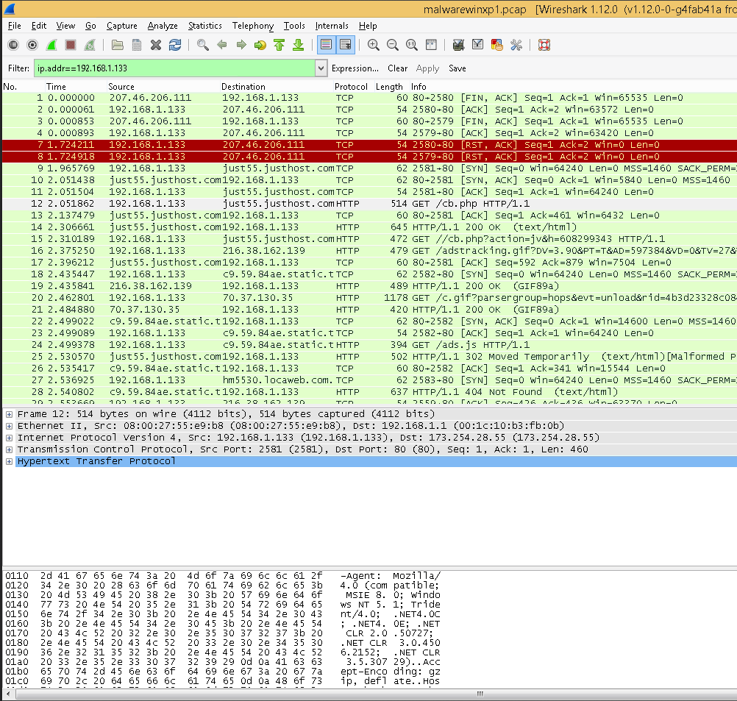
Menu
Main Toolbar
Filter Toolbar

Packet List Pane

Packet Details Pane

Packet Bytes Pane

- The host that was infected is 192.168.1.133. Create a filter of the traffic to only show transmissions to and from that host. Type the below filter command and hit enter.

- Check out Frame 12 in the Packet List Pane and you should see that the source is 192.168.1.133 (Victim’s IP) and the destination is 173.254.28.55 (Malicious Server)
- The “Info” column shows a GET request was made for cb.php which is the initial Exploit Kit script.
- In the menu, select “View” / “Name Resolution” / “Enable for Network Layer”
- You should now see the destination column for Frame 12 shows just55.justhost.com which is resolved from the IP address.
- However, we want to find out if justhost.com is the actual domain hosting the malicious script or if justhost.com is just offering shared web hosting under the 173.254.28.55 IP address.
- Look at the Packet Details Pane in Wireshark while Frame 12 is selected in the top panel. Expand the Hypertext Transfer Protocol view. Look at the “Host:” field and you should see the host contacted is “abrahamspath.org.uk.” That means the abrahamspath.org.uk domain is using justhost.com as their web hosting provider.
- Let’s create a new column in Wireshark for the “Host” field so that we can view the relationship in the top panel.
- In the menu, select “Edit” / “Preferences” / “Columns”
- Click the “Add” button at the bottom and change “Field type” to “Custom.” Change “Field name” to http.host and click “Apply.”
- In the upper window, click the “Title” of the column you created (it should say “New Column”) and change “New Column” to “Destination Host” and hit Enter.
- In the upper window, click on “Custom (http.host)” and drag it under the “Destination” title.
- The upper window should now look like the figure below:
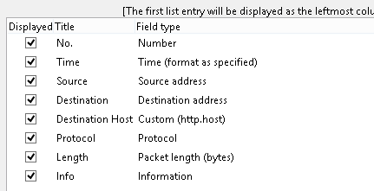
- Click “Apply” and then “OK.”
- You should now have your new “Destination Host” column in the Packet List Pane.
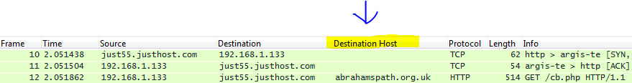

- You can adjust the width of the columns in the Packet List Pane to see everything.
- For Homework3, take a screen capture of the Packet List Pane (showing your new column) and upload it under Homework question number 1.
- Now we can clearly see the relationship of the Source, the Destination, and the Destination host. Remember, in this scenario the Source is the victim’s computer, the Destination is the hosting provider, and the Destination Host is the domain server hosting the exploit kit.
- Essentially in this packet capture, you will see a series of GET requests from the victim browser followed by an HTTP Status code. HTTP/1.1 200 OK means the GET request download from the malicious server was successful.
- Click on Frame 14 in the Packet List Pane and look at the “Line-based text data” in the Packet Details Pane.
- Notice that if Java is enabled on the victim, the top link should be visited.
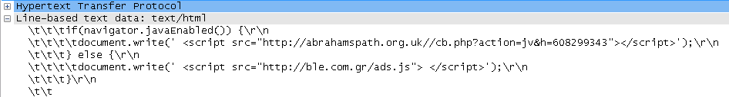

- Frame 15 shows the browser attempting to connect to the top link in the figure above which leads us to believe that Java was enabled in the victim’s browser.
- Now select Frame 25 and the “Info” column should display a 302 Moved Temporarily message.
- Expand the Hypertext Transfer Protocol view in the Packet Details pane (if it isn’t already) and look at the “Location” field. That tells us a redirection occurred to criagift.com.br.
- Now find criagift.com.br which should be Frame 35 and right click it and follow the TCP Stream.
- Everything in red text is what is being requested by the victim from the server. Everything in blue text is what the victim is receiving from the server in response to the GET request.
- Take some time and scroll down to see what is happening.
- In Homework3, question 3, explain what you think is occurring in the TCP Stream from Frame 35.
- Close the stream. Change the Filter drop down back to ip.addr == 192.168.133 and click “Apply.” (We will refer to this as the “original filter” for the rest of the lab.)
- Now, click on Frame 53 and look at the “Info” column. It tells you the enumeration of the victim determined that Java is on and let the malicious server know.
- Frame 61 shows the victim’s browser performed a DNS lookup for danieldelandy.com.
- Frames 69 and 70 show the download requests for two java browser exploits.
- The java exploits were successful as Frame 107 shows the browser requested a download of rh.exe.
- The java exploits then force the browser to execute rh.exe.
- If you were to analyze rh.exe, you would find out that it is a downloader Trojan. Its purpose is to check for Antivirus on the victim and disable it so that it can force the victim computer to download the real malicious payload.
- rh.exe first sends a DNS lookup for uploads.boxify.me seen in Frame 786.
- The payload rh.exe requests from the uploads.boxify.me server is shown in Frame 794 and is called Laine.lora.
- Frame 789 shows the java exploits telling the malicious server that they have loaded successfully.
- If you were to analyze Laine.lora you would see that it is a compressed archive made up of three malicious files. (We will analyze these in the next lecture.)
- rh.exe executes those three malicious files on the system.
- One of the three malicious files sends a POST to another malicious server in Frame 5145. Follow the TCP Stream and you should see:

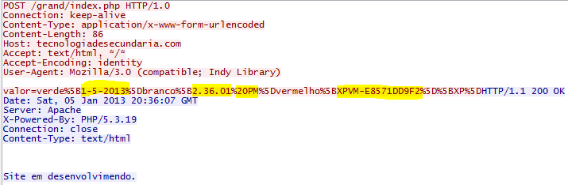

- The bottom of the figure above says Website in development in Portuguese.
- You can use a URL Decoder and then Google Translate on the “valor” string:

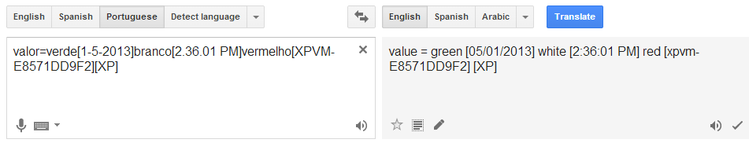

- You can see in the above figure that one of the malicious files sent the date and time of infection as well as the hostname and OS type of the infected computer.
- Close out of the TCP stream and return to the original filter.
Now, we will look at a way to see an overview of what happened in the exploit kit chain:

- In the menu, Select “Statistics” / “HTTP” / “Requests”
- Leave the filter in place and select “Create Stat”
- Expand all of the requests and you can see a nice simple view of the order in which everything happened. This is usually nice to do first before you start digging in. It is also a great way to see the network signatures of the exploit kit and do some google searching to determine which one it is.
- Next week we will analyze some of these malicious files. Luckily Wireshark has a quick way to extract all of the files downloaded during the exploit chain!
- Select “File” / “Export Objects” / “HTTP”
- You should now see the filenames and types of files these are.
- Normally, you would select “Save All” but don’t do this now. These are malicious files that will infect your machine. We will open the pcap in a VirtualBox VM next week and extract the files in there.
- Close Wireshark and turn Windows Defender back on.

